Visualization Tool For Electric Vehicle Change And Range Analysis

1. Introduction

1.1 Overview

* A vehicle that can be powered by an electric motor that draws electricity from a battery and is  
  capable of being charged from an external source and have an electric motor instead of an  
  internal combustion engine.
* The Electric Vehicle (EV) is not new, but it has been receiving significantly more attention in  
  recent years. Advances in both EV analytics and battery technologies have led to increased  
  automotive market share. However, this growth is not attributed to hardware alone.

1.2 Purpose

* The modern  
  mechatronic vehicle marries electrical storage and propulsion systems with electronic sensors,  
  controls, and actuators, integrated closely with software, secure data transfer, and data analysis,  
  to form a comprehensive transportation solution. Advances in all these areas have contributed to  
  the overall rise of EV’s, but the common thread that runs through all these elements is data  
  analytics.
* The new EV’s are combined Electrical storage and propulsion systems with electronic sensors,  
  controls, and actuators, integrated closely with software, secure data transfer to form a  
  comprehensive transportation solution.

2 Problem Definition & Design Thinking

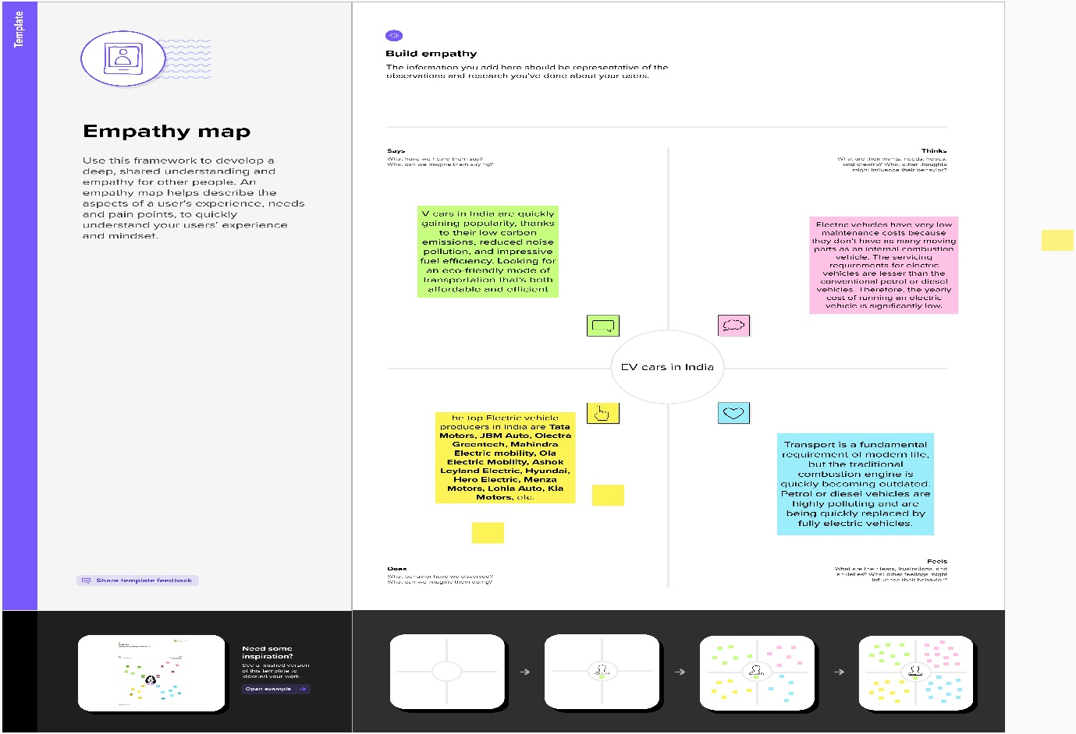 2.1 Empathy map

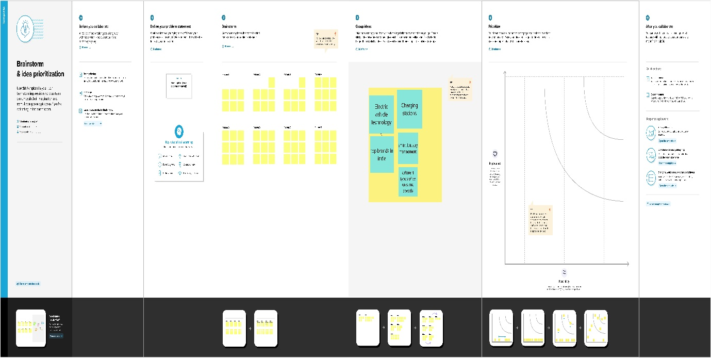2.2 brainstorming map screenshot

3 RESULT

3.1 DASHBOARD

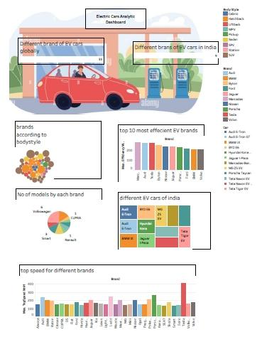

3.2 STORY

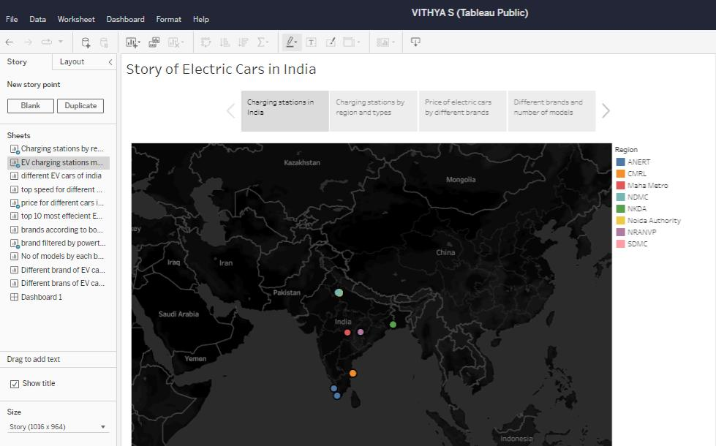

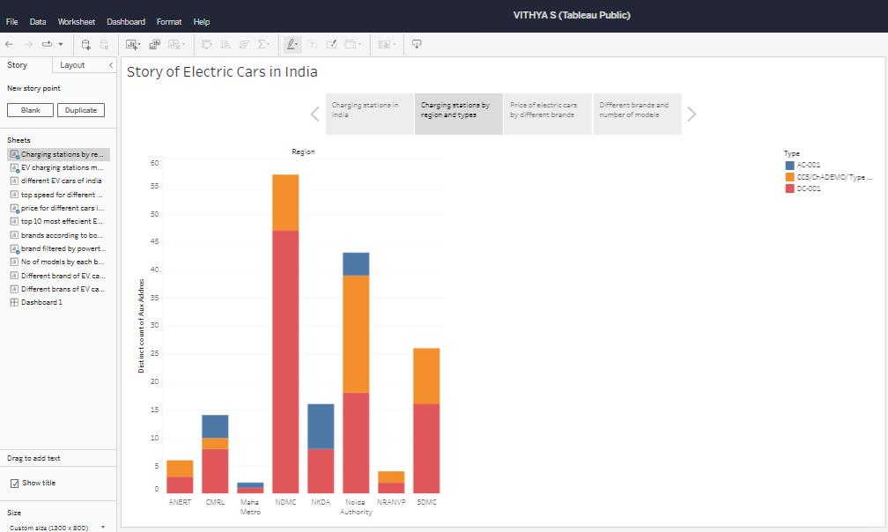

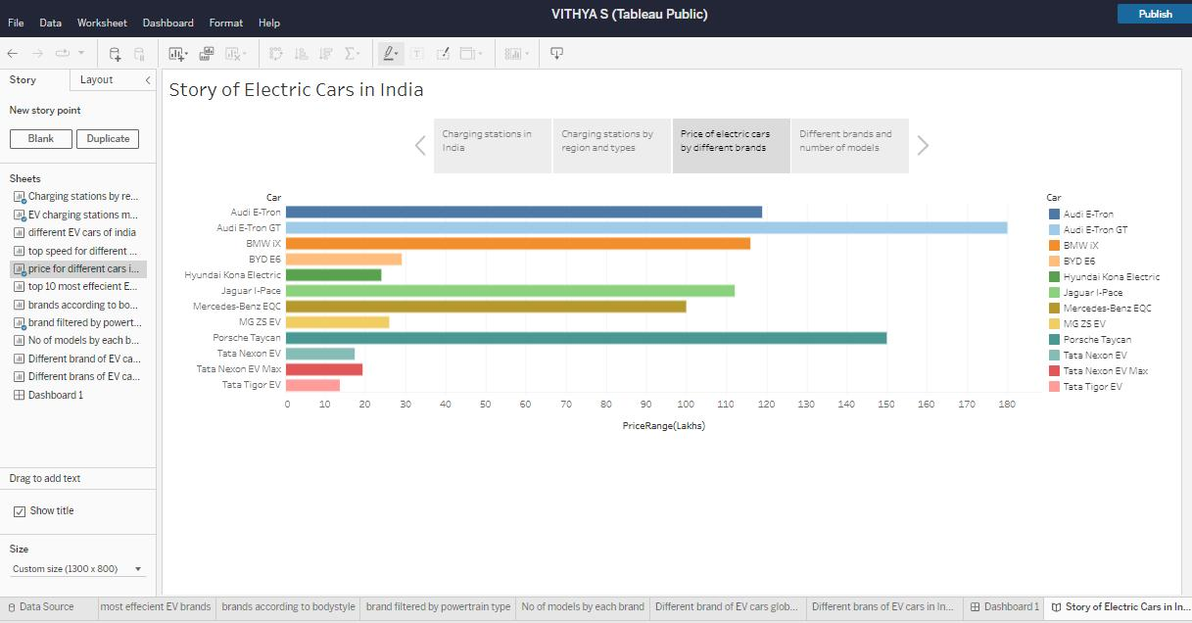

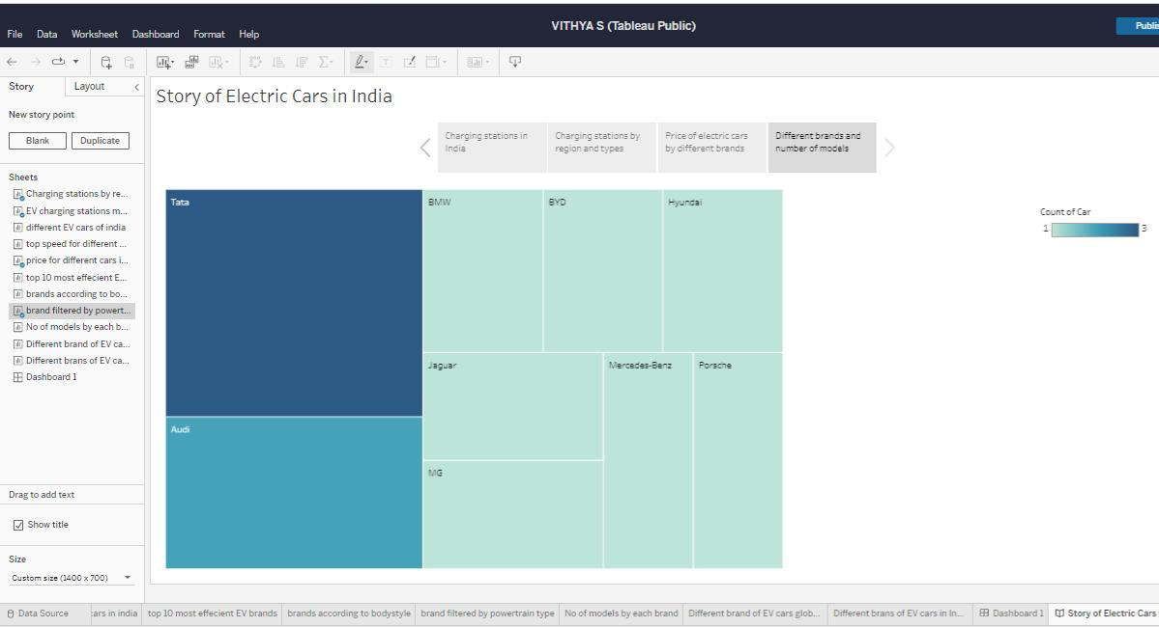

4 ADVANTAGES & DISADVANTAGES

4.1 ADVANTAGES

* No fuel required so you save money on gas.
* Environmental friendly as they do not emit pollutants.
* Lower maintenance due to an efficient electric motor.
* Better Performance.

4.1 DISADVANTAGES

* Limited Battery Range. The average petrol car can easily do four or five hundred miles on a tank of petrol.
* Battery Lifespan Concerns.
* Charging Infrastructure Worries.
* Long Charging Times.
* Low Top Speeds.
* More Expensive to Buy.

5 APPLICATIONS

Transformers & Power Engineering.

Electro-Structural.

Magnetic Gears.

Motors and Generators.

EV Battery Charging

6 CONCLUSION

This paper provided a thorough trendy review of the EV technologies, including EV charging methods such as BSS, WPT, and CC, EV charging standards, and optimization techniques for the design of optimal EV charging strategies. The paper discussed the limitations of the existing technologies. In addition, the paper identified some of the research suggestions that needed to be addressed. However, the paper did not investigate in terms of the manufacturing aspects since its focus was mainly on the standard and technologies.

7 FUTURE SCOPE

* The research on the application of BESS and bi-directional power transfer capability of EVs in a distribution system can reduce the global warming issue more resourcefully by providing green electricity to homes and offices. Also, the intermittency of PV can be reduced by integrating optimally sized BESS [[**80**](https://www.mdpi.com/2079-9292/10/16/1910#B80-electronics-10-01910)]. Also, the profit of the parking lot owner can be maximized by incorporating battery swap to provide added value to customers.
* The frequent charging/discharging can cause EV battery life degradation [[**81**](https://www.mdpi.com/2079-9292/10/16/1910#B81-electronics-10-01910)]. Therefore, the use of BESS as an energy storage backup and subsequent sale of electricity to the building instead of discharging the EV battery repeatedly will ultimately increase the battery lifespan.
* The proposed PEB charge scheduling algorithms [[**46**](https://www.mdpi.com/2079-9292/10/16/1910#B46-electronics-10-01910)] can be applied to the charging scheduling of private EVs and Electric Ferries where the arrival and departure schedules are known. The battery capacity optimization for a given route can also be evaluated to minimize the vehicle cost.
* Research should be carried out on coordinated charging because uncoordinated charging of EVs can cause a peak load on a distribution system. EVs could be a great solution to settle these complications. In general, most vehicles are parked during peak load time. Therefore, using the stored electricity from vehicle (battery) to grid (V2G), electrical peak load would be reduced.



8 APPENDIX

A.SOURCE CODE

Story

<https://public.tableau.com/shared/RF64W7TNB?:display_count=n&:origin=viz_share_link>

DASHBOARD

<https://public.tableau.com/shared/5FSJC56PC?:display_count=n&:origin=viz_share_link>